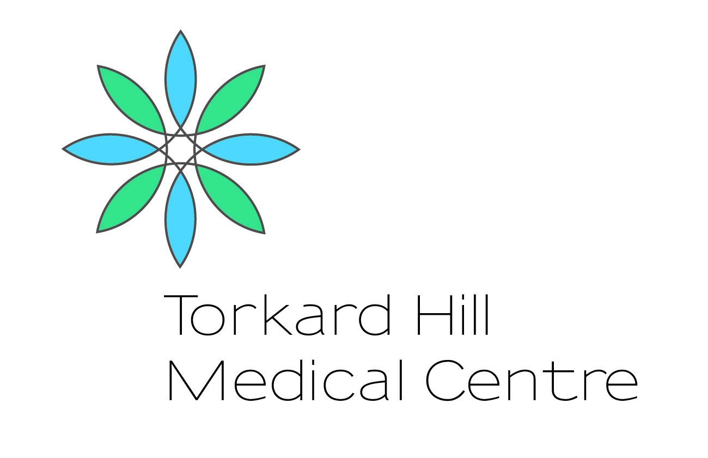
Torkard Hill Medical Centre
Comments, Complaints and Suggestions

Please help us get it right. We constantly try to improve the service we offer. Please let us know when you think we have done something well or if you have any suggestions as to how we can do something better.

Our address:
Torkard Hill Medical Centre, Farleys Lane. Hucknall, Notts NG15 6DY
Telephone: 01159 633676
http://www.torkardhill.co.uk
Practice Manager – NNESTCCG.AdminTorkard@nhs.net

Patient Full Name:
Date of Birth:
Address:

Details: (Include dates, times, and names of practice personnel, if known)

(Continue overleaf if necessary)

SIGNED……………… Print name………………………
DATE …………………………

